**Deployment of OrderItem**

**Step 1: Use the Same Kubernetes Cluster and Container Registry, After Successful Deployment add yaml file and update the repository and go to CI Pipeline**

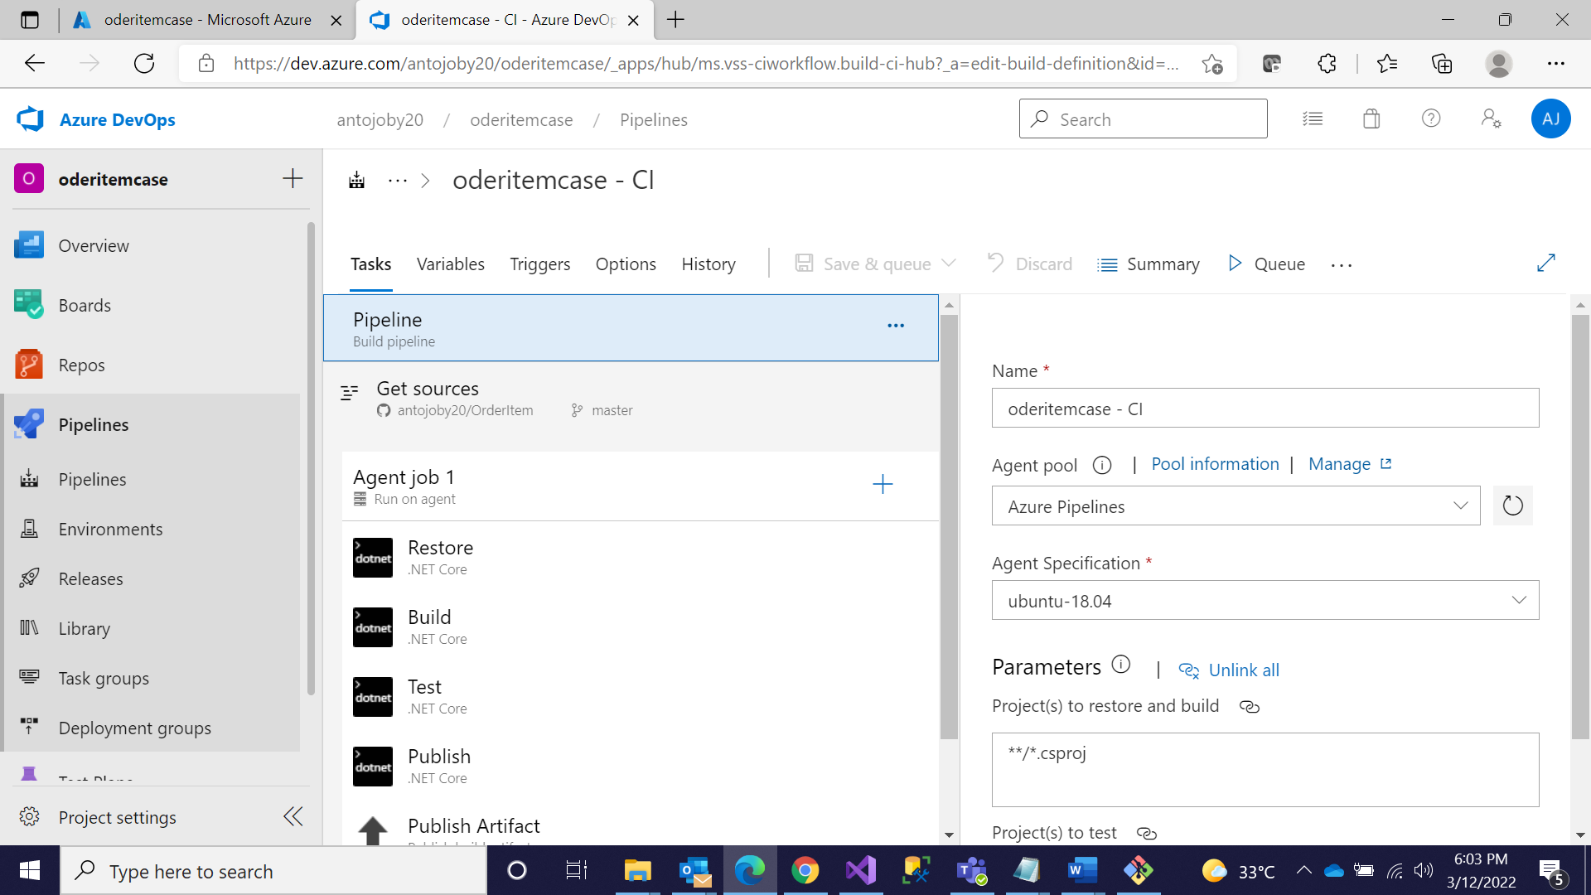

**Step 2: Go to Docker, In tags Type latest**

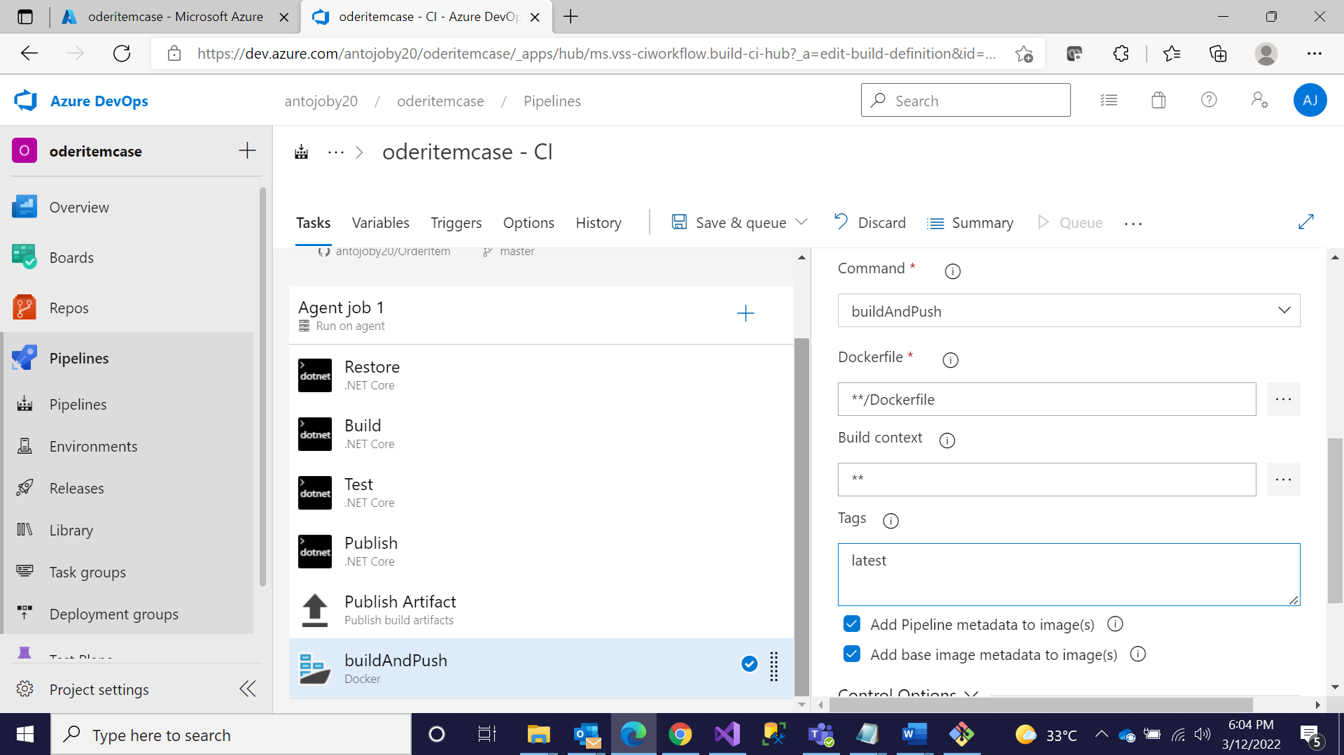

**Step 3: Click on publish and Uncheck Zip and Save**

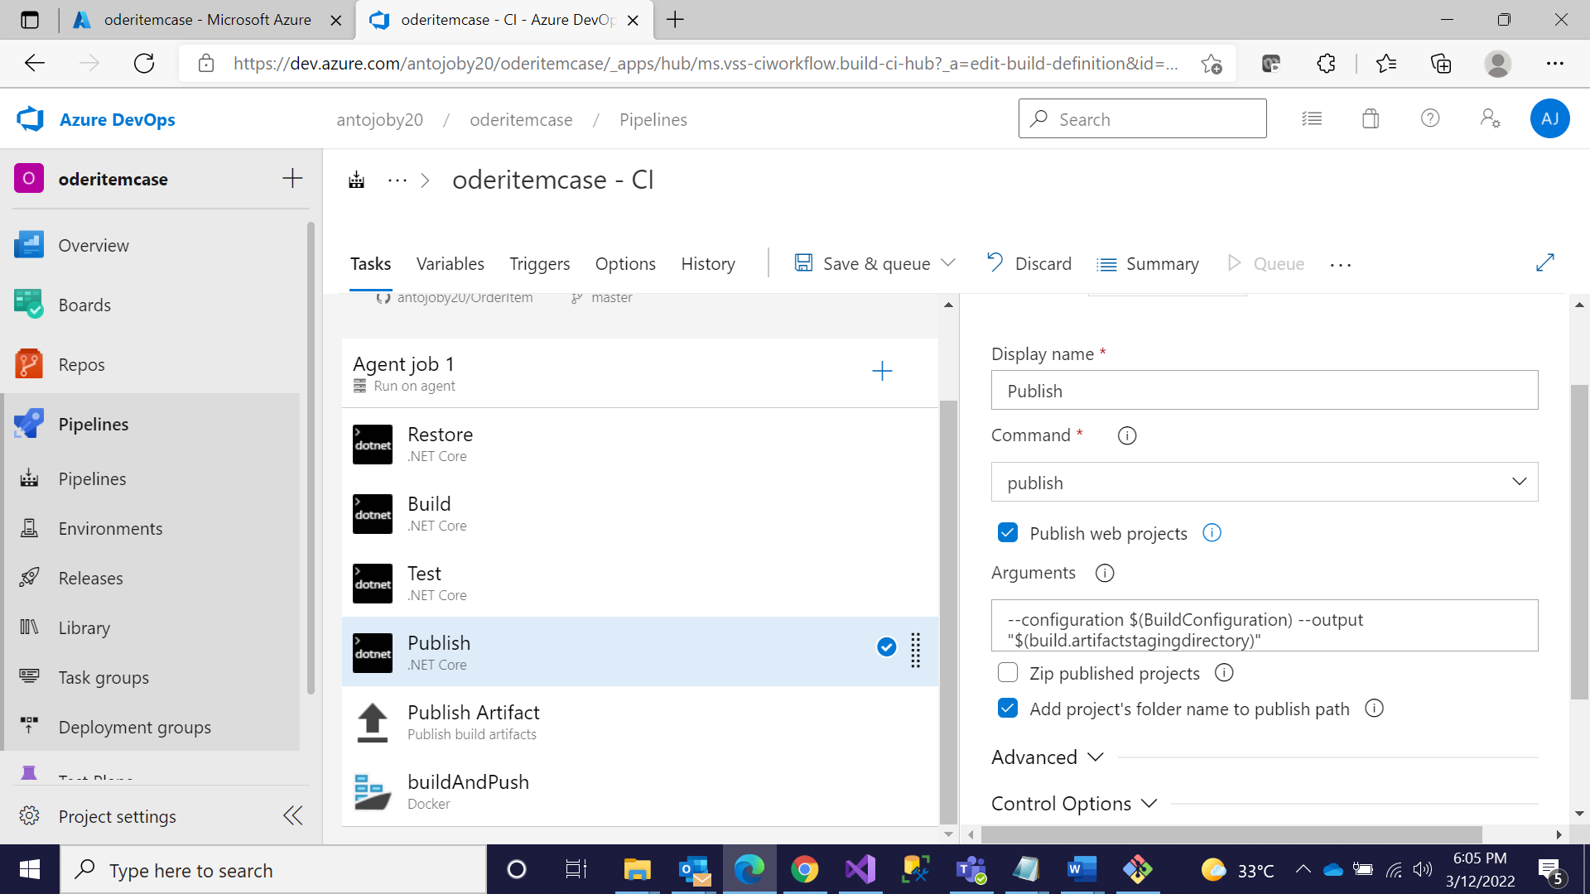

**Step 4: Go to CD pipeline and Edit**

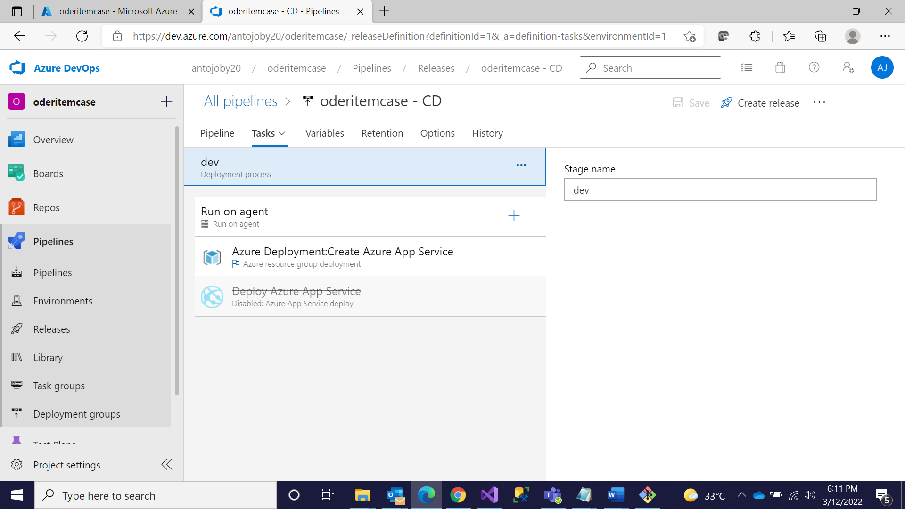

**Step 5: Disable both the tasks**

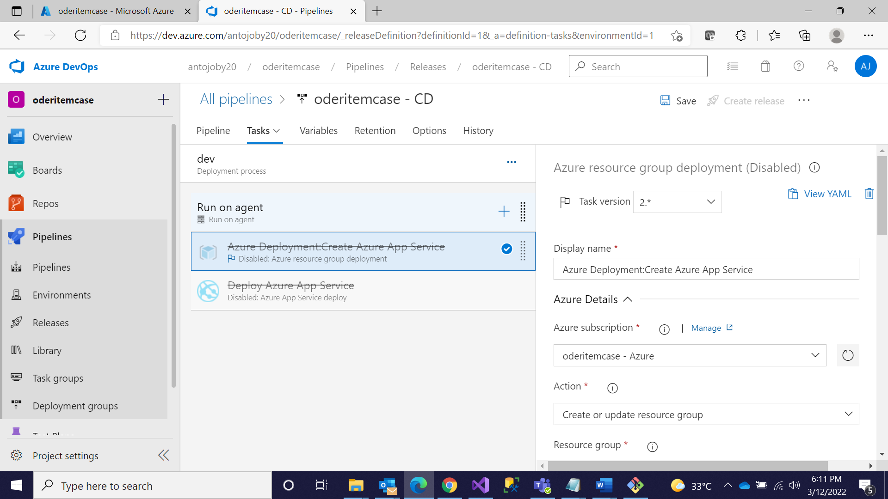

**Step 6: Add Kubectl and Give all the Credentials**

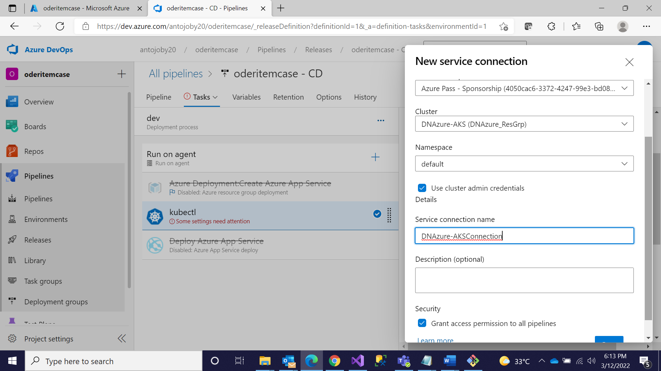

**Step 7: Give the Configuration and Add Yaml File**

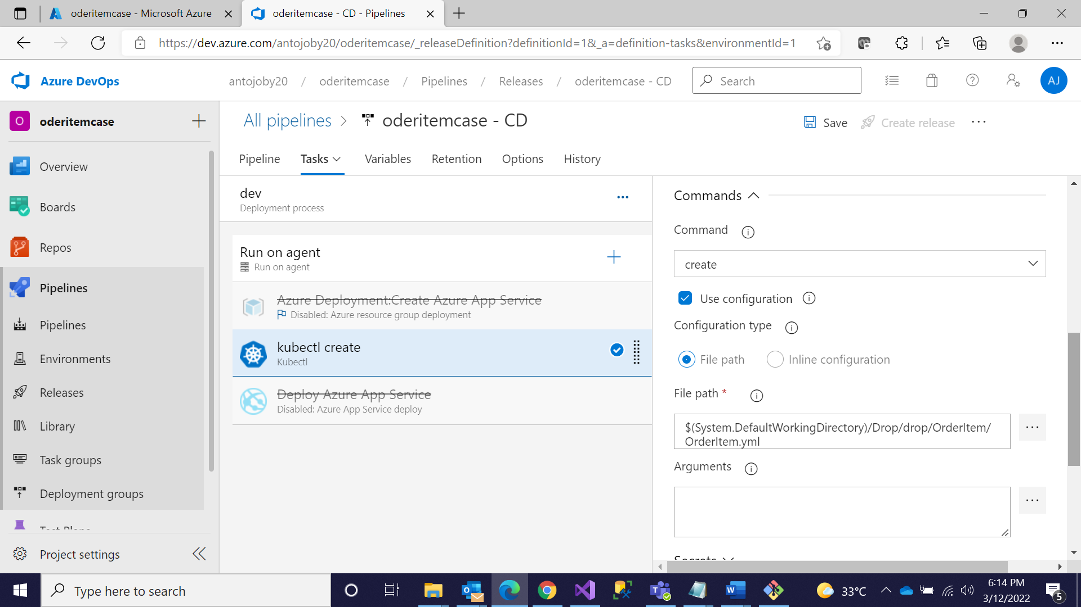

**Step 8: Give the Secret Key and all ,Save and Create Release**

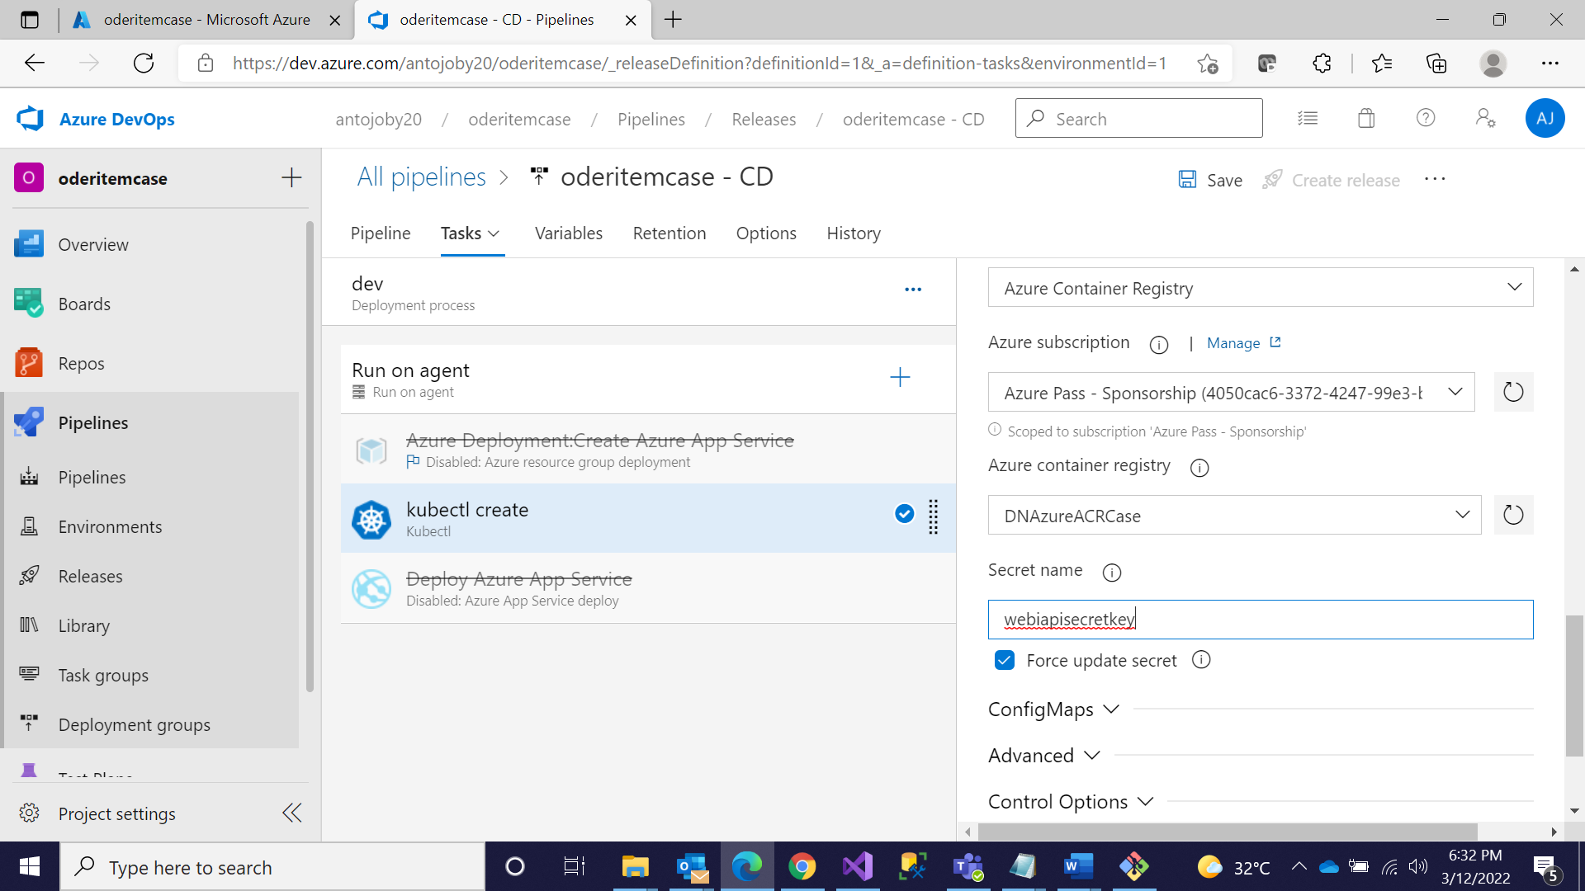

**Step 9: Go to Kubernetes Cluster and Click on Workloads**

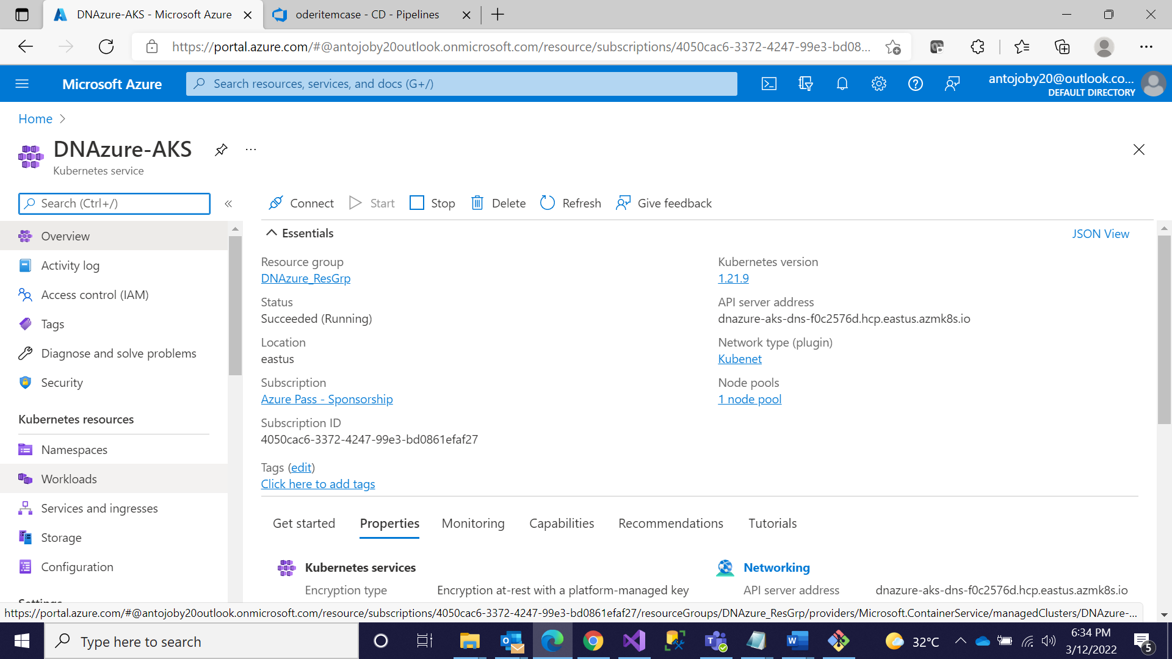

**Step 10: Successfully Deployed**

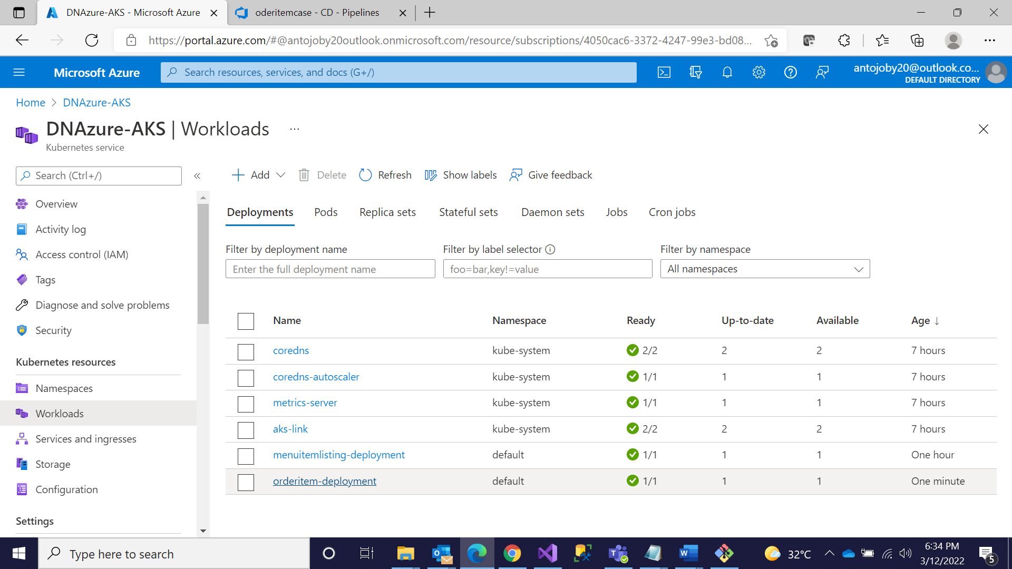

**Step 11: Go to Services and Ingresses and Click on the IP and Give Api/Controllername**

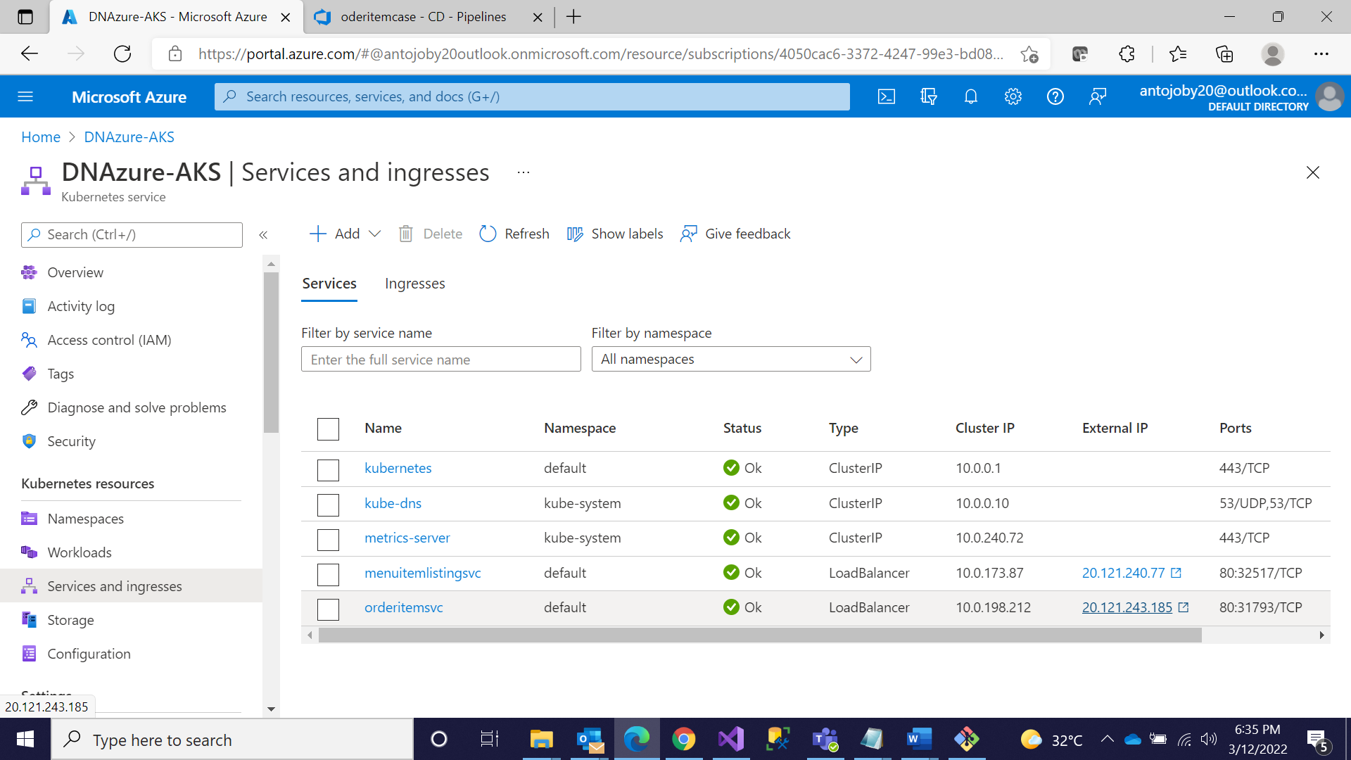

**Step 12: Successfully Deployed**

